Quick guide: Ulcerative Dermatitis (UD) in Rodents with High Fat Diets (HFD)

What is Ulcerative Dermatitis?
Ulcerative dermatitis in mice is a spontaneous, painful, and progressive condition associated with intense pruritus (itching) and self-trauma. It affects animal welfare and can introduce metabolic, inflammatory, and behavioral biases, particularly in studies involving high-fat diets. These diets increase the risk in susceptible strains. Late detection can lead to ulceration, secondary infection, and premature euthanasia.

Risk Factors
- Genetic background: C57BL/6 strain
- Mostly affects adult animals
- Consumption of high-fat diets: 10–24% fat (e.g., High-Fat Western Diet (HFWD), High-Fat diet (mast cell degranulation), High-Fat diet (experimental))
- Changes in environmental humidity: Normal range is 30–70%
- In aging studies, it should be taken into consideration that approximately 20% of mice will develop lesions compatible with ulcerative dermatitis.

Objective of the Guide
To prevent, detect, and manage ulcerative dermatitis (UD) in mice subjected to high-fat diets, ensuring animal welfare and data quality.

Monitoring
- Frequent locations: Cervical region, nape, upper back, ears, and face.
- Frequency: Once consumption of the HFD (High-Fat Diet) has begun, monitoring is recommended every 2 days. Once UD is detected, it is recommended to monitor the animal every 24 to 48 hours for 5 to 7 days. Once the lesion has stabilized (less pruritus, no increase in size, and dry scabs), it should be supervised every 3 to 5 days. Animals with chronic UD (scar fibrosis without progression) must be kept under chronic checks.
- Initial signs: Frequent scratching, small excoriations, alopecia with red skin.
- Signs of progression: Extensive scabs, ulcers, bleeding, infection.

Images

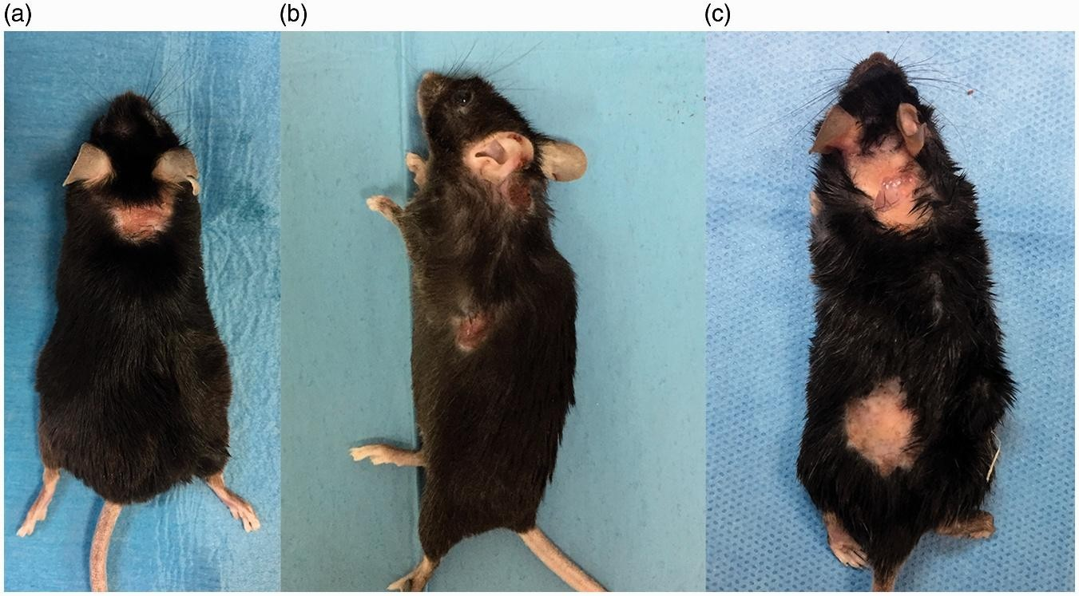
Figure 1. Typical presentation of murine ulcerative dermatitis showing focal areas of ulceration with fibrosis on the neck (a), upper dorsal thorax (b), and cervical and posterior areas (c).

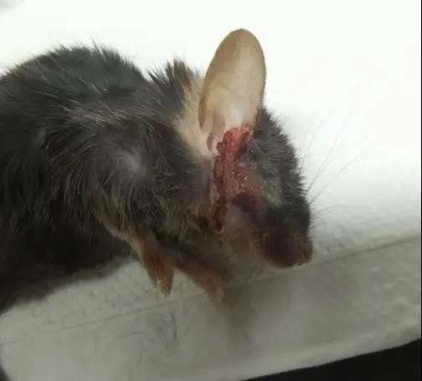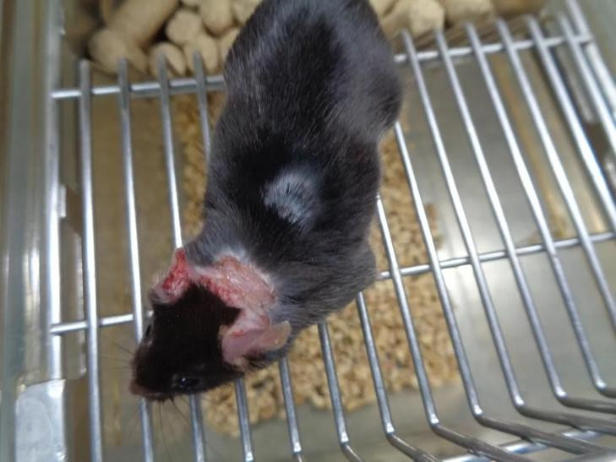
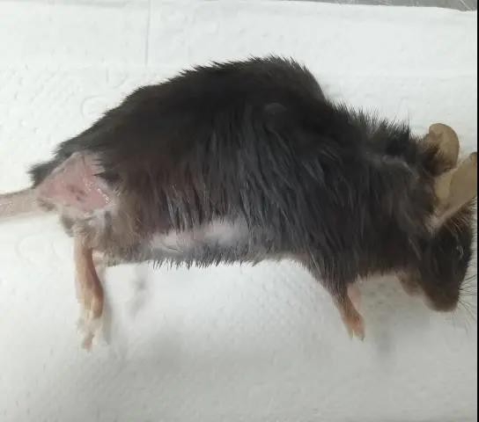
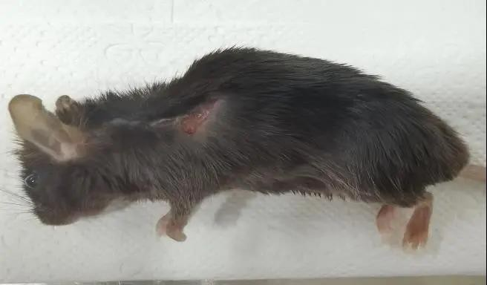
Figure 2. The images show animals that suffered from varying degrees of UD; open, moist wounds with signs of self-trauma can be observed in them.

Preventative Measures
- Baseline clinical evaluation of the skin.
- Diet records (brand, % fat).
- Prophylactic nail trimming before starting the diet, to be repeated according to nail growth.
- Stable housing (avoid facility transfers) and environmental enrichment.

Action Upon Lesions
- Notify the veterinarian immediately.
- Record the lesion/injury (date, animal, description, photographic record).
- Therapeutic nail trimming.
- Treatment only under veterinary direction.
- Re-evaluate continuity in the protocol.

Application of Severity Score Card*

The guideline will only be applied once the diagnosis of UD has been confirmed, which compiles the following information:

Dimension | Scale (0-3)
Type of lesion | Intact (0), Excoriation (1), Scab (2), Ulcer (3)
Affected surface area | 0%, <1%, 1–5%, >5%
Length | No lesion, <1 cm, 1–2 cm, >2 cm
Regions | None, 1, 2, ≥3
Calculation: Severity (%) = (Total Score / 12) × 100
Classification: 0–25% mild | 26–50% moderate | 51–75% high | >75% severe (consider euthanasia).

Figure 3: Example of the application of the severity scoring system for ulcerative dermatitis (UD) in C57BL/6 mice. Three clinical evaluations with different degrees of involvement (from mild to severe) are illustrated, considering the character of the lesion (COL), body surface area affected (BSA), length of the lesion, and number of regions involved. Source: Hampton et al., 2012. Reproduced for educational purposes.

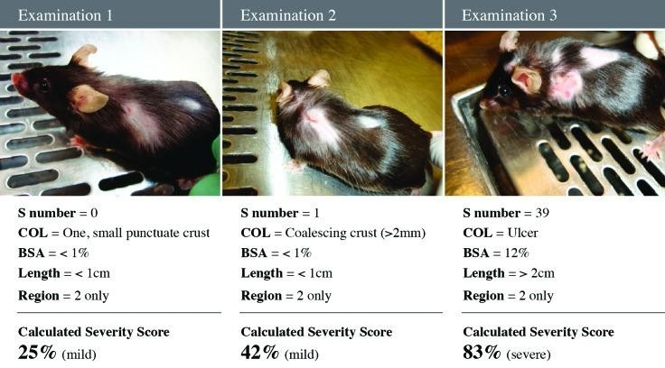

Endpoints or Escalation Criteria
Open ulceration, ocular/oral involvement, persistent pain, lack of response to treatment.

*For more information, please review the Severity Score Card accompanying this guideline.
Severity Quantification Score Card
Ulcerative Dermatitis (UD)
This score card allows for the objective quantification of the degree of involvement of ulcerative dermatitis.

Animal Identification

Protocol Code | Animal ID | Strain | Diet (HFD)
Severity Assessment

Dimension | 0 | 1 | 2 | 3
Type of Lesion (COL) | Intact skin | Excoriation / punctate scab | Coalescing scab  (>2 mm) | Erosion / ulcer
Affected Surface Area (BSA) | 0 % | < 1 % | 1–5 % | > 5 %
Size / Length | No lesion | < 1 cm | 1–2 cm | > 2 cm
Affected regions | None | 1 region | 2 regions | ≥ 3 regions
Score Calculation
- Total score (sum) / 12
- Severity (%) = (score / 12) × 100 = %

Classification:
- 0–25 % Mild
- 26–50 % Moderate
- 51–75 % High
- > 75 % Severe (consider humane endpoint) Observations:

Supervisor Signature: Date:
Severity Quantification Guidelines – Ulcerative Dermatitis (UD)
This guideline is based on the Ulcerative Dermatitis Severity Score (UDSS) system described for C57BL/6 mice and adapted for operational use in clinical supervision by the CEC-CAA. Dimensions assessed
Each animal must be evaluated considering four dimensions, which are scored and then integrated into a severity percentage.
- Character of Lesion (COL)

Score | Description
0 | Intact skin, no lesion
1 | Mild excoriation or punctate scab
2 | Coalescing scab (> 2 mm)
3 | Erosion or open ulcer

- Body Surface Area Affected (BSA)
Visual estimation of the percentage of compromised body surface area.

Score | Affected Surface Area
0 | 0 %
1 | < 1 %
2 | 1–5 %
3 | > 5 %

- Size / Linear Extension of the Lesion (Length)
The maximum length of the primary lesion is considered.

Score | Length
0 | No lesion
1 | < 1 cm
2 | 1–2 cm
3 | > 2 cm

- Number of affected body regions (Region)

Score | Regions compromised
0 | None

1 | 1 region
2 | 2 regions
3 | ≥ 3 regions

- Calculation of the severity score
  - Sum the scores obtained in A + B + C + D.
  - Maximum possible score: 12 points.
  - Calculate severity percentage:

Severity (%) = (Score obtained / 12) × 100

Classification of the degree of affection
The classification of the degree of affection guides the intensity of the measures to be implemented. In all cases classified as severe, the final decision must be made through veterinary evaluation and, when applicable, in conjunction with the MVI and the committee.

Severity(%) | Classification | Interpretation
0–25 % | Mild | Initial lesion, local management, and prevention
26–50 % | Moderate | Requires active intervention and frequent supervision
51–75 % | High | High risk of progression, evaluate continuity
> 75 % | Severe | Consider humane endpoint

