Guide to Pre- and Post-Surgical Recommendations in Rodents

Section 1 – General considerations and surgical environment

Justification for applying aseptic technique in rodent surgery

Although mice and rats have been considered resistant to post-surgical infections, the literature contains numerous articles documenting how subclinical infections such as Pseudomonas aeruginosa, Corynebacterium kutscheri, or murine hepatitis virus can turn into clinical diseases following situations of stress or immunosuppression.
Historically, surgery in rodents has been performed non-aseptically or with poor aseptic technique. However, experimental evidence has shown that infections take on a subclinical (and clinical) profile in rats and mice. An improvement in post-operative recovery has been documented through increased food and water consumption thanks to the implementation of aseptic surgical techniques.

Purpose of this guide

The purpose of this guide is to provide guidance on pre and post-surgical practices to researchers, veterinarians, students, and professionals dedicated to scientific research who use laboratory animals in their studies. Likewise, it is aimed at undergraduate and postgraduate students who are starting or participating in research projects with similar characteristics.

Regulations and Guidelines

The Guide for the Care and Use of Laboratory Animals (National Research Council) states: "An inadequate or incorrect technique can lead to subclinical infections that can cause adverse physiological and behavioral responses, affecting surgical success, animal welfare, and research outcomes."

The American College of Laboratory Animal Medicine (ACLAM 2016) declares: "Managing the stress response through effective surgical, anesthetic, and perioperative care practices is essential to safeguard the validity and reproducibility of research results and to ensure the health and welfare of rodents used in surgical models. Laboratory animal researchers and veterinarians promote quality research and high standards of animal health and welfare through intensive surgical training, thorough pre-surgical planning, and careful execution of IACUC-approved surgeries."

At the national level, Law 20,380 on animal protection, in its 7th article mentions: "experiments on live animals may only be practiced by qualified personnel, who will avoid their suffering to the maximum extent possible." Qualified personnel shall be understood as those who have studies in the fields of veterinary medicine, medicine, or related sciences, certified by an academic institution of the State or recognized by it. If the experiments consist of surgical interventions that necessarily require the use of anesthesia to avoid unnecessary suffering, they must be performed by a veterinarian or another competent professional. Furthermore, such experiments must be carried out in appropriate facilities and shall be limited to the purposes outlined in the preceding article. The establishments where these experiments are conducted must have facilities suitable for the respective species and categories of animals, in order to prevent mistreatment and the deterioration of their health."

Special Considerations

- Rodents have a high body surface area-to-volume ratio and a fast metabolism, meaning they dehydrate and lose heat easily. Hypothermia is a frequent cause of intraoperative mortality. The use of hot water bottles or heating bags (filled with water or seeds) is not recommended because temperature cannot be effectively controlled, which can cause injury to the patient.
- Surgical stress generates hormonal and metabolic responses (hyperglycemia, negative nitrogen balance). Minimizing tissue trauma, preventing infections, and managing pain reduces these responses and promotes recovery.

Section 2 – Preoperative Preparation and Anesthesia

Preoperative Preparation of the Animal

- Evaluate the health status of the animal prior to the procedure using the monitoring guidelines of the approved protocol.
- For the adaptation of animals to a new environment, allow at least 3 days of acclimatization following transport prior to surgery.
- For surgical procedures in which the animals are expected to be returned to their place of origin post-intervention, the adaptation time to the location may fluctuate according to what is approved in the animal care and use protocol.
- The animal must be free of clinical signs of illness: normal posture and movement, a glossy coat, clear eyes, and normal breathing and coloration. Applying the pre-procedure monitoring checklist is essential.
- Food and water intake must be normal.
- If experimental conditions permit, fasting mice and rats is not necessary, as they cannot vomit. Prolonged fasting of 8 to 12 hours can cause hypoglycemia and significant changes in the intestinal microflora (dysbiosis and enterotoxemia).
- Special care must be taken with pregnant females regarding the choice of analgesia, anesthesia, and positioning during surgery.

Positioning of the Animal

- Avoid excessive tension on the limbs, which can cause nerve damage or compromise circulation.
- Secure the limbs with tape to the designated procedure table for the intervention.
- Never use the body of the anesthetized animal to support materials.

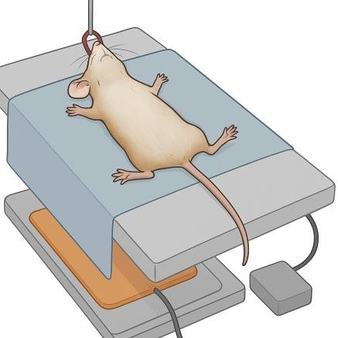
Figure 1: Positioning of the animal. Image generated with AI.

General Preparations for Surgery

A clean, orderly, and disinfected area dedicated exclusively to surgery is required during the procedure.

Proper disinfection of surfaces where surgical procedures are performed on rodents is essential to maintain aseptic conditions and prevent post-operative infections. Work surfaces, surgical trays, and support equipment must be cleaned before, between procedures, and at the end of the surgical session.

General Cleaning and Disinfection Procedure
- Pre-cleaning to remove visible organic material (bedding debris, blood, hair, or biological fluids).
- Apply an approved disinfectant compatible with the surfaces.
- Respect the contact time indicated by the manufacturer to ensure antimicrobial efficacy.
- Allow air drying before starting surgery or placing sterile barriers if applicable.
- Repeat the process between animals and at the end of the session.
- Record the procedure in the corresponding logbook or record sheet (date, product, person in charge).
- Personnel must wear gloves and eye protection according to the product used.

Recommended Products
The following agents are recommended for surface disinfection in rodent surgery:
Type of Disinfectant | Recommended Use | Observations
70% Ethanol or 70–85% Isopropanol | Quick cleaning between surgeries | Avoid prolonged contact with acrylics; flammable
0.5–1% Sodium Hypochlorite (fresh bleach solution) | High-level disinfection | Inactivated by organic matter; corrosive; requires rinsing
0.05–2% Chlorhexidine Solutions | Surfaces and trays; compatible with biological fluids | Good residuality; use formulations suitable for surfaces
Quaternary Ammoniums | Routine and inter-procedure | Effective in the absence of organic matter
Hydrogen Peroxide (incl. accelerated peroxide) | Surfaces, equipment, rooms | Broad spectrum and good user safety
Phenols | Areas with high organic matter | Avoid on plastic due to progressive damage
Glutaraldehyde (restricted use) | Non-critical/high-level equipment | Limited use due to toxicity and required ventilation

Select the product based on surface compatibility, required level, and institutional regulations.
- Separate the areas of animal preparation, operative field, and recovery.
- Avoid high-traffic zones and drafts.
- Surgical instruments must be sterilized in an autoclave, packaged, and with valid sterility indicators.
- Between surgeries, instrument tips can be re-sterilized in a hot bead sterilizer (see Annex 2).
- This method should not be used for more than 5 consecutive surgeries without switching to a new set of sterilized instruments.
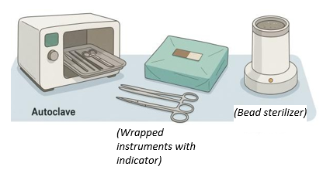

Figure 2: Methods of sterilization of surgical material. Image generated with AI.

Prevention of Hypothermia

- Rodents lose heat rapidly under anesthesia.
- Use homeothermic blankets, recirculating warm water blankets, or heat lamps (with monitoring).
- Place the animal on insulating material (e.g., bubble wrap, gauze).
- Keep the tail over the heat source whenever possible.
- Begin applying heat immediately following anesthetic induction.

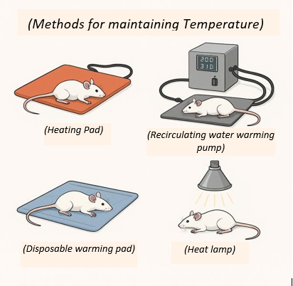

Figure 3: Methods for maintaining body temperature in rodents. Image generated with AI.

Anesthesia
The use of inhalation anesthesia (isoflurane or sevoflurane) with a precision vaporizer is the method of choice. Below are recommendations for the application of inhalation anesthesia:

Inhalation Anesthesia (isoflurane or sevoflurane)
The method of choice for rodents is inhalation anesthesia administered via a precision vaporizer and supplemental oxygen.

Induction
- Place the animal in an induction chamber or nose cone.
- Isoflurane 3–5% (or equivalent concentration of sevoflurane).
- Confirm surgical anesthetic plane:
  - Loss of righting reflex
  - Decrease in respiratory rate (↓ ~50 % relative to baseline).
  - Absence of response to painful stimulus (pedal reflex).

Maintenance
- Isoflurane 1–2% depending on animal response, procedure, and species.
- Administer via nose cone or intubation (if applicable).
- Continuous monitoring every 10–15 min, record in the anesthesia log:
  - Respiratory rate
  - Mucous membrane color
  - Body temperature
  - Pedal reflex

Recovery
- Discontinue anesthetic, maintain oxygen if possible.
- Place in a recovery cage with heat >37 °C.
- Supervise until:
  - Upright posture
  - Normal breathing
  - Full recovery of alertness

Aspect | Recommendation
Temperature | Heating pad or warmer suitable for rodents
Eyes | Lubricate if the procedure lasts >5 min
Safety | Check circuits and connections before each use
Gas scavenging | Charcoal canister, fume hood, or downdraft table
Canister management | Weigh and record date and weight after each procedure

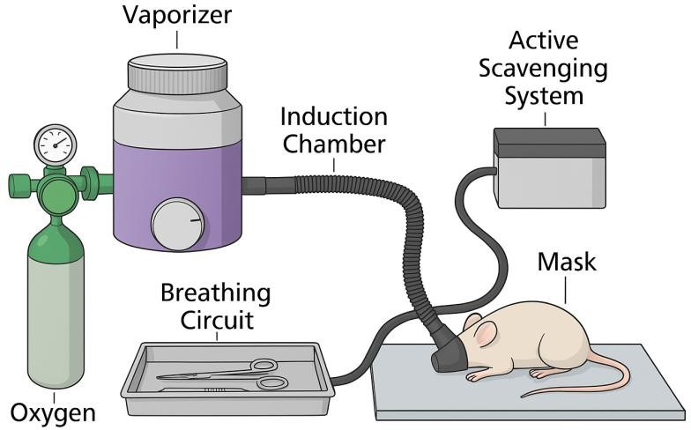
Induction can be performed in a chamber and maintenance via a face mask or endotracheal tube, depending on the technique and training of the operator. This procedure must be complemented by individual clinical records, veterinary supervision, and evidence of training in anesthetic techniques.

Figure 4: Inhalation anesthesia method. Image generated with AI.

Alternative Induction Method (Open Drop)

The open-drop method consists of applying liquid anesthetic onto cotton or a sponge inside an induction chamber, ensuring no direct contact with the animal. It is used only for brief induction and must be performed under a fume hood.

Recommendations
- Saturated cotton contained within a perforated vial, attached to the inner lid. Separating grid.
- Animal placed at the base of the chamber.
- Fume hood in operation.
- Upon loss of the pedal reflex → transfer to a mask with vaporizer.
- Cotton: 0.5–1 g per liter of chamber volume.
- Isoflurane: 0.2 mL of liquid per liter of chamber volume (≈4% vapor)
- Separate the cotton from the animal using a grid or a perforated container.
- Maximum induction time of 1–2 min, then continue via mask with vaporizer.
- Do not use for prolonged procedures due to the risk of mortality and toxicity.

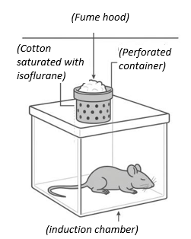

Figure 5: Alternative method of open-drop anesthesia. Image generated with AI.

Guideline values based on animal welfare standards. For exclusive use in brief induction, with immediate transition to a mask and vaporizer.

Chamber Volume | Amount of Cotton  (approx.) | Recommended Liquid Isoflurane | Estimated Chamber Concentration | Use
0.5 L | 0.25–0.5 g  (4×4 cm  approx.) | 0.1 mL | ~4% | Mouse (rapid induction)

1.0 L | 0.5–1 g (5×5  cm approx.) | 0.2 mL | ~4% | Mouse / rat pup
2.0 L | 1–2 g (7×7  cm approx.) | 0.4 mL | ~4% | Small / juvenile rat

- Always keep the cotton isolated (using a grid or perforated vial).
- Do not allow direct contact between the animal and the anesthetic.
- Target maximum induction time: < 1–2 minutes.
- Use under a fume hood or with active extraction.
- After induction → remove the cotton, ventilate the chamber, and transfer to a mask.
The use of a vaporizer is the recommended standard. Open-drop should only be used when a vaporizer is unavailable, and its use is justified in a protocol approved by the CEC-CAA.

Preemptive Analgesia
- Preemptive analgesia consists of administering local anesthetics or systemic analgesics prior to the incision.
- Objective: To decrease the transmission of painful stimuli and improve postoperative recovery.
- It is recommended to inject an analgesic 15 to 30 minutes before the surgery ends, depending on the type of pain expected from said procedure (e.g., NSAIDs or local anesthetics). The route of administration will depend on the drug's package insert, which must be reviewed beforehand.
- Ideally, analgesia should be maintained for a period of 48 to 72 hours.
- It is recommended to infiltrate lidocaine into the incision site before starting.
- Lidocaine 1–2% (max. 10 mg/kg, duration 20–40 min).

Section 3 – Surgical Technique

Hemostasis
- Minimize and control bleeding during surgery.
- Blood loss promotes bacterial growth, delays recovery, and increases the risk of death.
- To reduce hemorrhage: Dissect following tissue planes, identify and retract large vessels, and apply hemostatic techniques (direct pressure, cautery, hemostatic products, ligatures).

Tissue trauma and contamination

Basic principles:
- Surgery must be gentle: rough tissue manipulation increases pain, infection, and recovery time.
- Time equals trauma: Prolonged exposure of organs to room temperature is harmful. Avoid procedures lasting >90 min.
- Keep tissues moist using warm sterile saline or Lactated Ringer's solution.
- If contamination occurs, irrigate with abundant warm sterile solution.

Risk Factors
- There is no 100% guarantee of sterility. The objective is to reduce microorganisms to safe levels.
- The risk depends on the type and duration of the procedure, the animal's condition, the surgeon's experience, instrument preparation, and compliance with aseptic technique.

Suture Materials
- Internal layers: Absorbable sutures (e.g., Vicryl, PDS, Dexon). Sizes: 4-0 to 6-0 in rats; 5-0 to 7-0 in mice.
- Skin: Non-absorbable monofilament sutures (Prolene, nylon, stainless steel), clips, or tissue adhesives.
- Avoid braided sutures like silk on the skin (risk of infection)

Suture Patterns

- Abdominal wall: Simple continuous or interrupted pattern using absorbable suture.
- Subcutaneous tissue: Continuous closure with absorbable suture in large/obese rats; not required in mice.
- Skin: Interrupted suture with non-absorbable monofilament, surgical clips, or tissue adhesive. Spacing should be 5–8 mm.
- In animals prone to chewing external sutures, a subcuticular pattern or surgical clips are preferred.
- Closure must restore proper tissue alignment without using excessive suture material.

Knots and Security

- Tie secure square knots (3–4 throws for internal layers, 5–6 throws for skin).
- Do not cut the tags too short (risks the knot untying).
- Avoid excessively long tags on the skin (animals may chew on them).

Tissue Adhesives
- May be used for small, tension-free wounds.
- Apply in thin layers, avoiding excess that could stimulate the animals to groom or manipulate the wound.
- Advantages: Rapid application, no need for suture removal, and inherent antimicrobial properties.
- Contraindicated for wounds under tension.
- There are several available on the domestic market: Dermabond®, Histoacryl Blue®, Epiglu®, VetBond®, among others.

Use of Antibiotics

- They do not replace aseptic technique.
- They should be reserved for cases of immunodeficiency, surgery on hollow organs, biomaterial implantation, accidental contamination, or highly invasive procedures.
- In general, a single preoperative dose of a broad-spectrum antibiotic may be sufficient.
- Considerations: Normal microbiota Lactobacillus spp. and Bacteroides spp. are destroyed by antibiotics; this will lead to an overgrowth of opportunistic organisms, particularly Escherichia coli and Clostridium spp.
- Antibiotics commonly associated with dysbiosis include: cephalosporins, lincomycin, penicillins, clindamycin, erythromycin, vancomycin, bacitracin, and oral gentamicin.

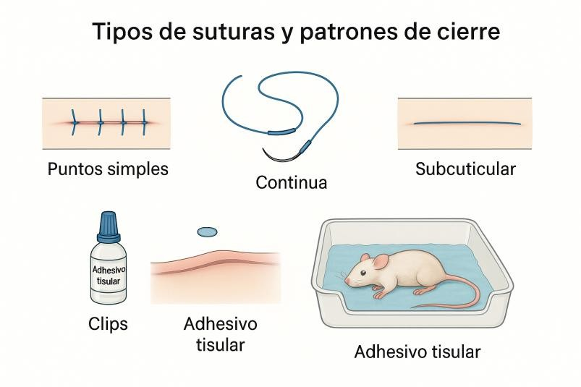
Tissue adhesive
Tissue adhesive
Subcuticular
Continuous suture
Simple interrupted sutures
(Suture types and closure patterns)
Figure 6: Suture types and closure patterns. Image generated with AI.

Section 4 – Postoperative Care

Recovery and Monitoring
- Use anesthetic antagonists whenever possible to accelerate recovery (e.g., atipamezole for ketamine/xylazine).
- Continue applying external heat with electric warming blankets (specifically designed for this purpose) until the animal recovers its righting reflex.
- Place the animal in a clean cage with fresh bedding to minimize wound contamination.
- For the first 24 hours, it is recommended to house animals individually per cage to prevent cage mates from interfering with the wound.
- Monitor food and water intake over several days. Food and water should be placed on the cage floor to facilitate easy access for the patient.
- Evaluate signs of dehydration (skin turgor test) and administer subcutaneous or intraperitoneal fluid therapy if necessary. A volume of 100 mL/kg of body weight is recommended, via either the subcutaneous (SC) or intraperitoneal (IP) route. Keep in mind the maximum fluid volume tolerance for each route of administration.
- Weigh the animals daily or use a Body Condition Scoring system (BCS; see Annex 1) to monitor general health status.
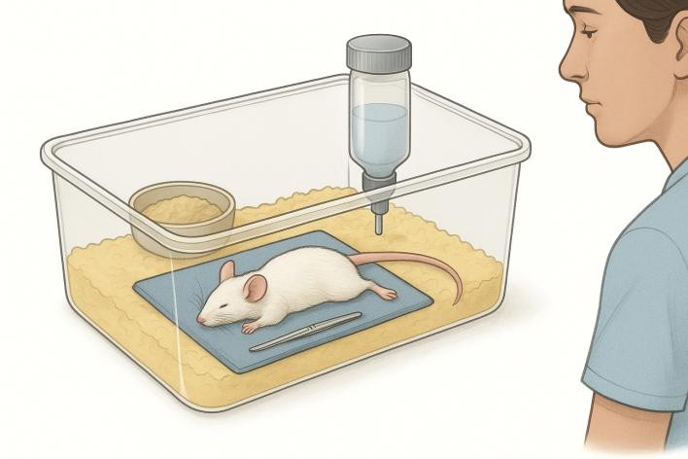
Figure 7: Postoperative recovery and monitoring. Image generated with AI.

Analgesia and Pain Management

- If a procedure is painful in humans, it must be assumed to be painful in rodents as well.
- For surgeries involving major pain, it is recommended to maintain analgesia for 48 to 72 hours.
- Provide adequate analgesia starting in the immediate postoperative period.
- Observe for signs of pain: Hunched posture, piloerection, decreased activity, vocalization, red discharge around the eyes/nose, and changes in appetite or weight.
- The first 24 hours are critical for pain management.
- Neonates and animals recovering from prolonged surgeries may require oral glucose to prevent hypoglycemia.

Nutrition and support

- Rodents have high metabolic demands and low-fat reserves.
- Offer moist, palatable, and high-energy food as soon as they recover (diet gels, soft diets, flavored supplements).
- Prioritize soft foods that are easy to access (placing them directly on the floor of the cage.

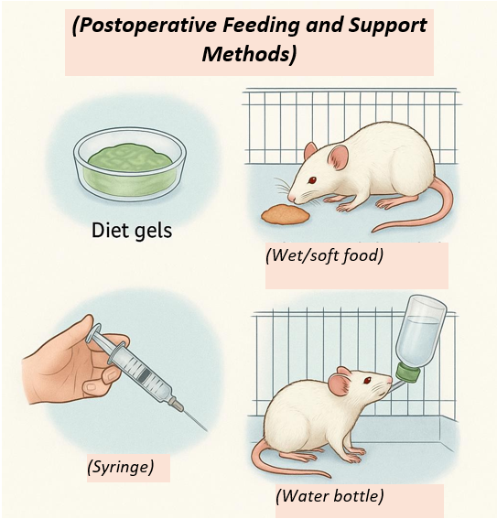

Figure 8: Postoperative feeding and support methods. Image generated with AI.

Postoperative Record

- Document the animal's daily progress, wound status, and drug administration in the monitoring score sheets approved by the CEC-CAA for each experimental protocol.
- Maintain these records for at least 5 days following the surgery.
- Monitoring cards or sheets must include: date, animal identification, surgical site, drugs administered, observations, and the signature of the responsible personnel.

Non-Pharmacological Pain Management Methods

- Keep the animal in a quiet environment with low lighting.
- Control ambient room temperature and prevent hypothermia.
- Avoid any unnecessary handling.
- Maintain adequate hydration using warm fluids.
- Allow the animal to recover in the company of cage mates once it is safe to do so or after the initial 24 hours, in order to promote thermoregulation and reduce stress.

DEFINITIONS

- Asepsis: A state in which living pathogenic organisms are absent; a condition approaching sterility.
- Aseptic surgery: Performing an operation using gloves, sterile instruments, etc., while taking precautions against the introduction of infectious microorganisms from the external environment.
- Major survival surgery: Penetrates and exposes a body cavity, produces substantial physical or physiological impairment, or involves extensive tissue dissection (e.g., laparotomy, thoracotomy, limb amputation).
- Minor survival surgery: Does not expose a body cavity and causes little or no physical impairment (e.g., wound suturing, peripheral vessel cannulation, percutaneous biopsies). Animals recover with minimal complications.
- Contaminated/Colonized: Presence of microorganisms (<10⁶/gram of tissue}
- Disinfection: A chemical or physical process that destroys pathogenic organisms. Disinfectants are effective against vegetative forms, but not necessarily against spores.
- Sterilization: A process by which all viable microorganisms are eliminated or destroyed. The criterion for proper sterilization is the failure of organisms to grow in an appropriate culture medium.
- Sterile: Free from all living microorganisms and their spores.
- Infected/Sepsis: Presence of microorganisms (<10⁶/gram of tissue}, with clinically evident infection.

References
- Chile. Ministerio de Salud. Subsecretaría de Salud Pública. (2009). Ley 20.380 sobre protección de animales.
http://www.leychile.cl/N?i=1006858&f=2009-10-03&p=
- National Research Council. (2011). Guide for the care and use of laboratory animals (8th ed.). The National Academies Press.
https://doi.org/10.17226/12910
- Perret-Gentil, M. I. (s.f.). Guía de cirugía en roedores: Aplicación de la técnica aséptica y cuidados perioperatorios. Laboratory Animal Resources Center, University of Texas at San Antonio.
- Ullman-Culleré, M. H., & Foltz, C. J. (1999). Body condition scoring: A rapid and accurate method for assessing health status in mice. Laboratory Animal Science, 49(3), 319–323. PMID: 10403450.
- American College of Laboratory Animal Medicine. (2020). ACLAM position statement: Rodent surgery standards.
- American Veterinary Medical Association. (2020). AVMA guidelines for the euthanasia of animals. AVMA.
- National Institutes of Health, Office of Animal Care and Use. (2023). Rodent survival surgery guidelines. NIH.
- Orr, H. (2017). Rodent surgical guidelines. ORR Safety Program.
- University of Iowa Institutional Animal Care and Use Committee. (2023). Guidelines for rodent survival surgery.
- University of California, Los Angeles. (2022). Rodent surgery policies and procedures. UCLA.
- University of Rochester Medical Center. (2023). Aseptic recovery surgery policy for rodents and birds.
- American Association for Laboratory Animal Science. (2017). Anesthesia and analgesia in laboratory animals. AALAS Learning Library.
- Fish, R. E., Brown, M. J., Danneman, P. J., & Karas, A. Z. (Eds.). (2011). Anesthesia and analgesia in laboratory animals (2nd ed.). Academic Press.
- Hawkins, P., Playle, L., Golledge, H., et al. (2016). Guidance on the severity classification of scientific animal procedures. Laboratory Animals, 50(1), 1–23. https://doi.org/10.1177/0023677215571759
- Laboratory Animal Science Association. (2019). Guidance on the use of volatile anesthetics for rodents. LASA.

ANNEX 1: Body condition scoring in rodents
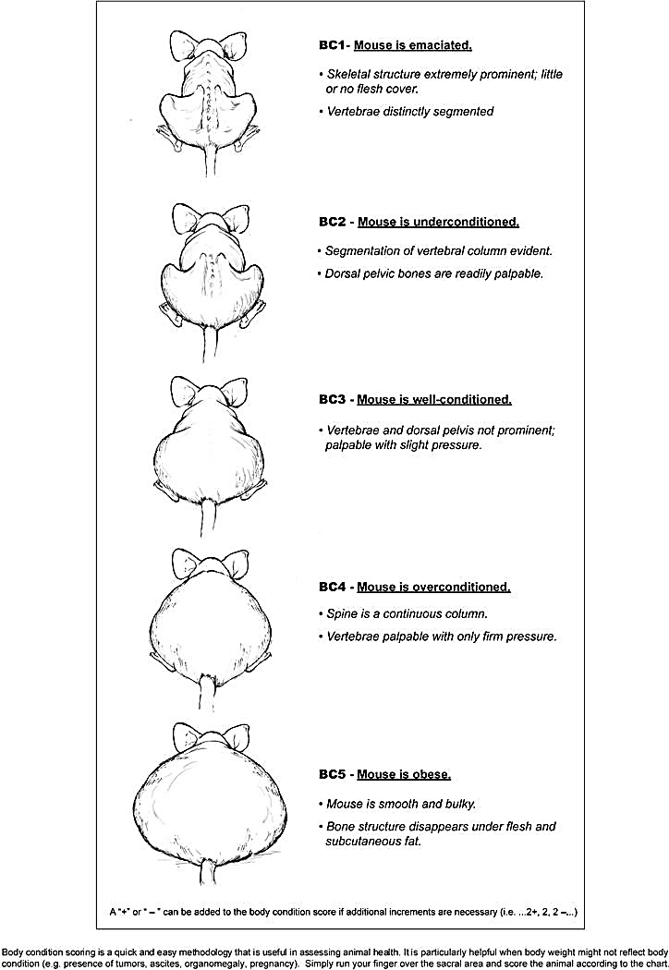

ANNEX 2: USE OF THE HOT GLASS BEAD STERILIZER
The hot glass bead sterilizer allows for the rapid re-sterilization of metallic instruments during rodent surgeries, eliminating the need to autoclave between each animal.
Procedure
- Preheat the equipment to operating temperature (≈ 200–250°C).
Wait until the indicator shows a stable temperature.
- Remove organic debris from the instrument immediately after use:
  - Remove tissue or blood using sterile gauze moistened with sterile saline or 70% alcohol
  - Dry before inserting into the beads (to prevent abrupt vaporization).
- Insert only the active tip of the instrument (do not submerge the handles or complete joints unless necessary).
- Leave the instrument inside for 10–15 seconds or according to the manufacturer's recommendation.
- Remove and allow to cool briefly on a sterile surface (or sterile material) before reusing to prevent tissue burns.

Considerations
- Use to maintain sterility between animals, not as the initial method of sterilization (instruments must start the day sterilized by autoclave).
- Do not insert instruments with visible organic debris → this decreases efficacy and damages the beads.
- Replace the beads according to the manufacturer's instructions or when they show signs of wear/contamination.
- Keep the equipment on a stable and well-ventilated surface.
Important: Do not apply this method to heat-sensitive materials or instruments with plastic parts.

ANNEX 3: Rodent Surgery Checklist
Application of aseptic technique and perioperative care.

Preoperative
  - The animal was clinically evaluated and is in good health.
  - A minimum acclimation period was respected, as approved in the protocol evaluated by the CEC-CAA
  - The animal was NOT subjected to prolonged fasting.
  - A clean, disinfected area free of excessive traffic was prepared.
  - A surgical table equipped with a heat source (warming blanket, lamp, or recirculating water pad) was set up.
  - Sterile instruments were prepared on a wrapped tray or autoclave.
  - An intraoperative re-sterilization method is available (hot glass bead sterilizer).
  - The surgical site was shaved and prepped with an appropriate antiseptic.
  - Preemptive analgesia and/or local anesthesia was applied where applicable.
  - Animal and procedure data were recorded on the corresponding sheet.

Perioperative (During surgery)
  - The surgeon uses sterile gown, gloves, and mask.
  - A sterile drape is used to delimit the surgical area.
  - Aseptic technique was used at all times (instruments, gloves, handling).
  - Anesthetic depth was monitored (reflexes, respiratory rate).
  - The animal's eyes were protected with ophthalmic ointment.
  - Body temperature was maintained throughout the entire procedure.
  - Appropriate hemostasis and gentle tissue handling techniques were employed.
  - Appropriate sutures, clips, or adhesives were used according to tissue type.
  - Proper layered closure was performed (if applicable).
  - Surgical time was kept as brief as possible.

Postoperative
  - The animal was placed in a clean cage with fresh bedding and a quiet environment.
  - External heat was secured until the recovery of the righting reflex.
  - Vital and recovery signs were observed until the animal was alert.
  - Postoperative analgesia was administered as planned.
  - Palatable/soft food and accessible water were offered from the start of recovery.
  - Food and water consumption was verified within the first 24 hours.
  - The animal was weighed (or body condition score was evaluated) daily according to the frequency indicated in the monitoring protocol approved by the CEC-CAA
  - All observations and treatments were documented on the follow-up sheet.
  - The surgical wound was checked daily and its progress/evolution was recorded.
  - The removal date for sutures, clips, or adhesives was indicated (if applicable).

